Here are the results of labwork 02 (tasks 2-3):

**Task 2. Configuring Oracle Linux Enterprise 6.1**

Task 2.1 Network and DNS Configuring

Screenshots of ping localhost and resolving virtual machine name (after configuring name of Virtual machine) are presented below.

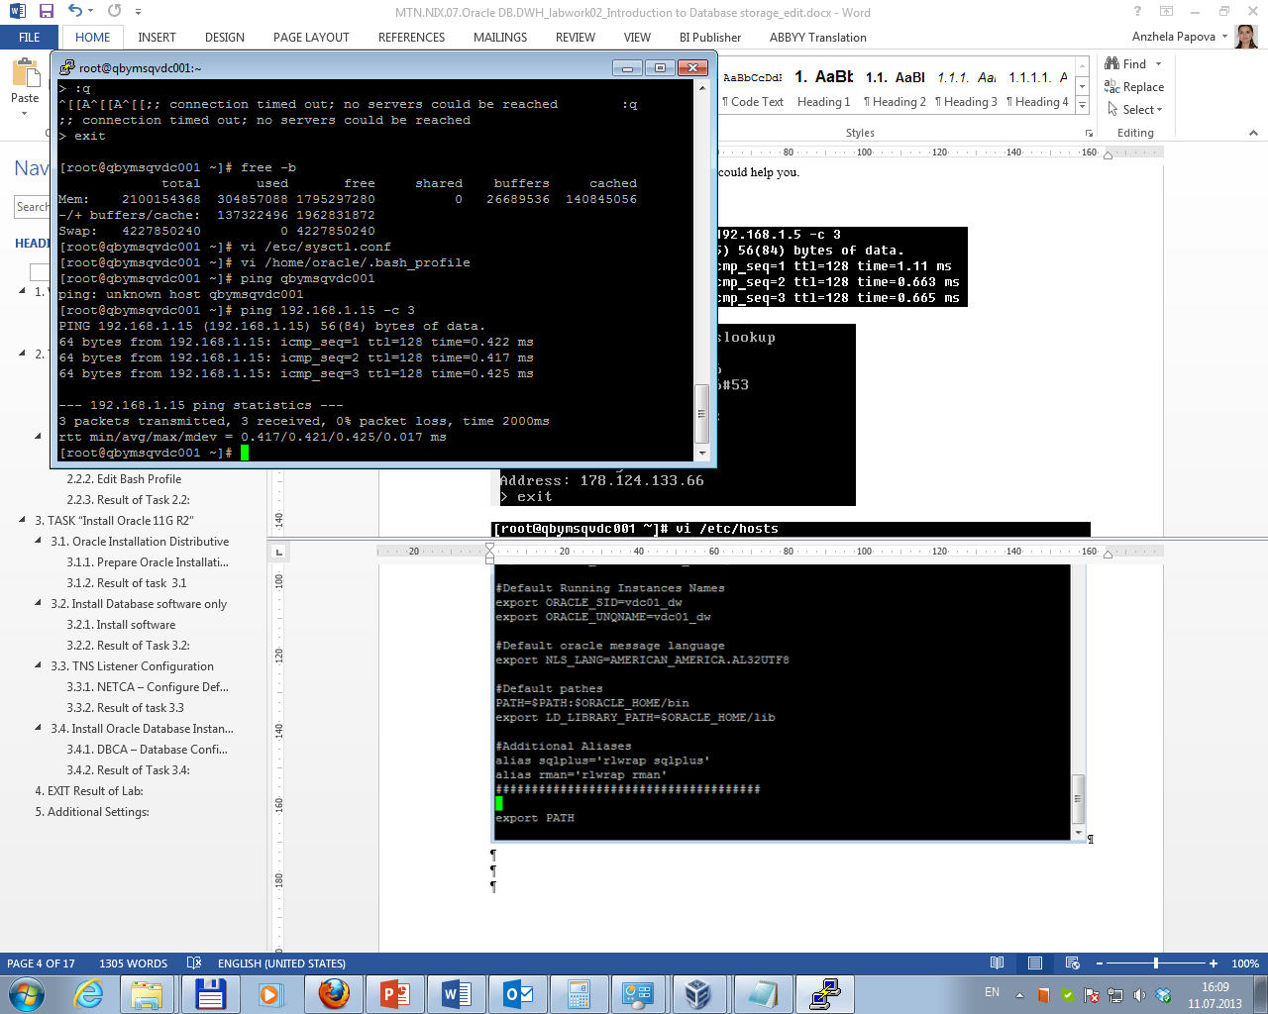

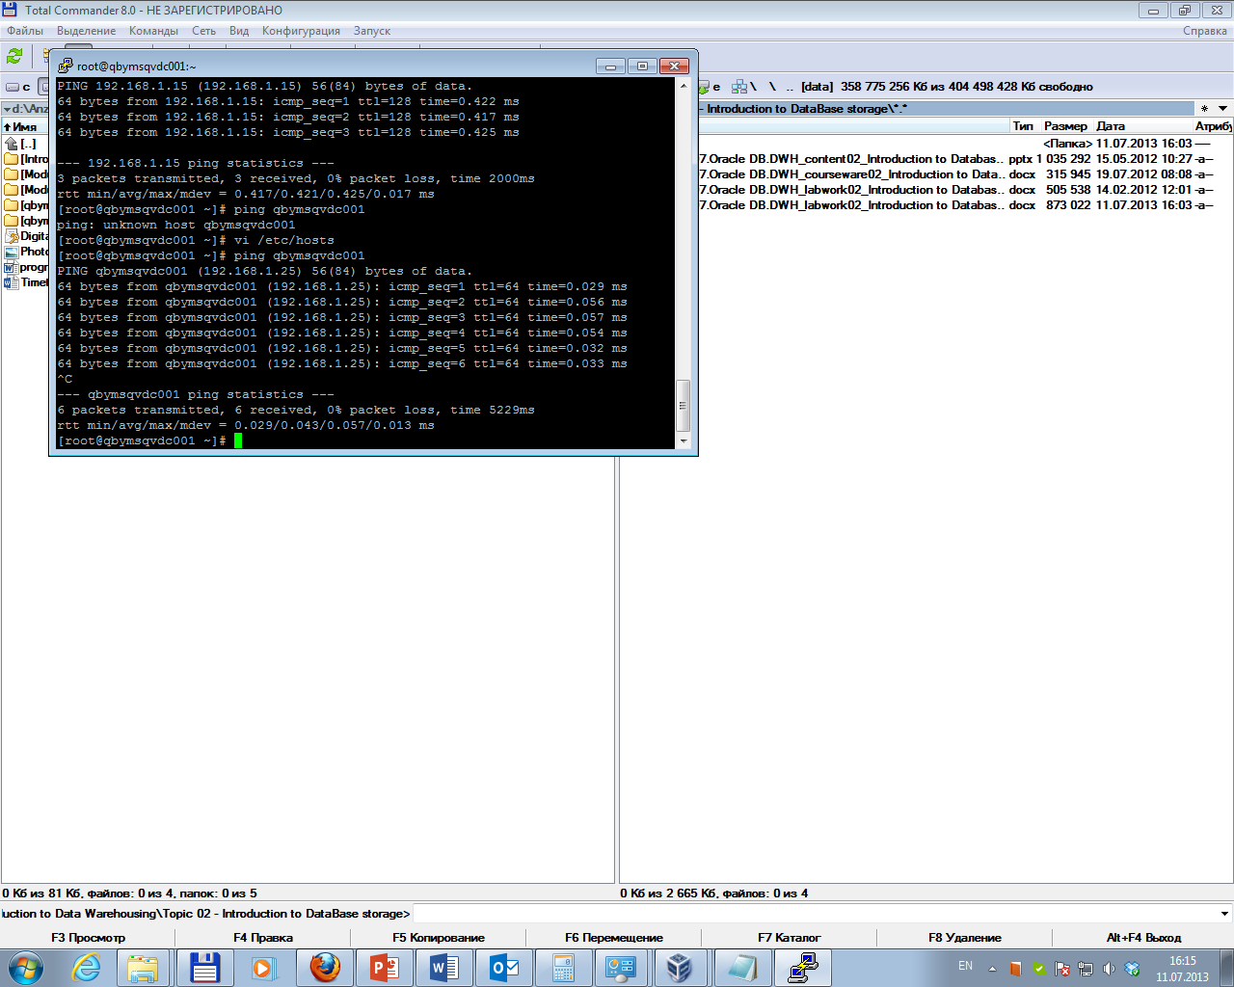

Task 2.2 Configuring BASH Profile and Core Parameters

Parameters were rechecked by running command: vi /etc/sysctl.conf.

Bash-Profile was rechecked by running command: vi /home/oracle/.bash_profile. Screenshot of configured and rechecked Bash-Profile is presented below.

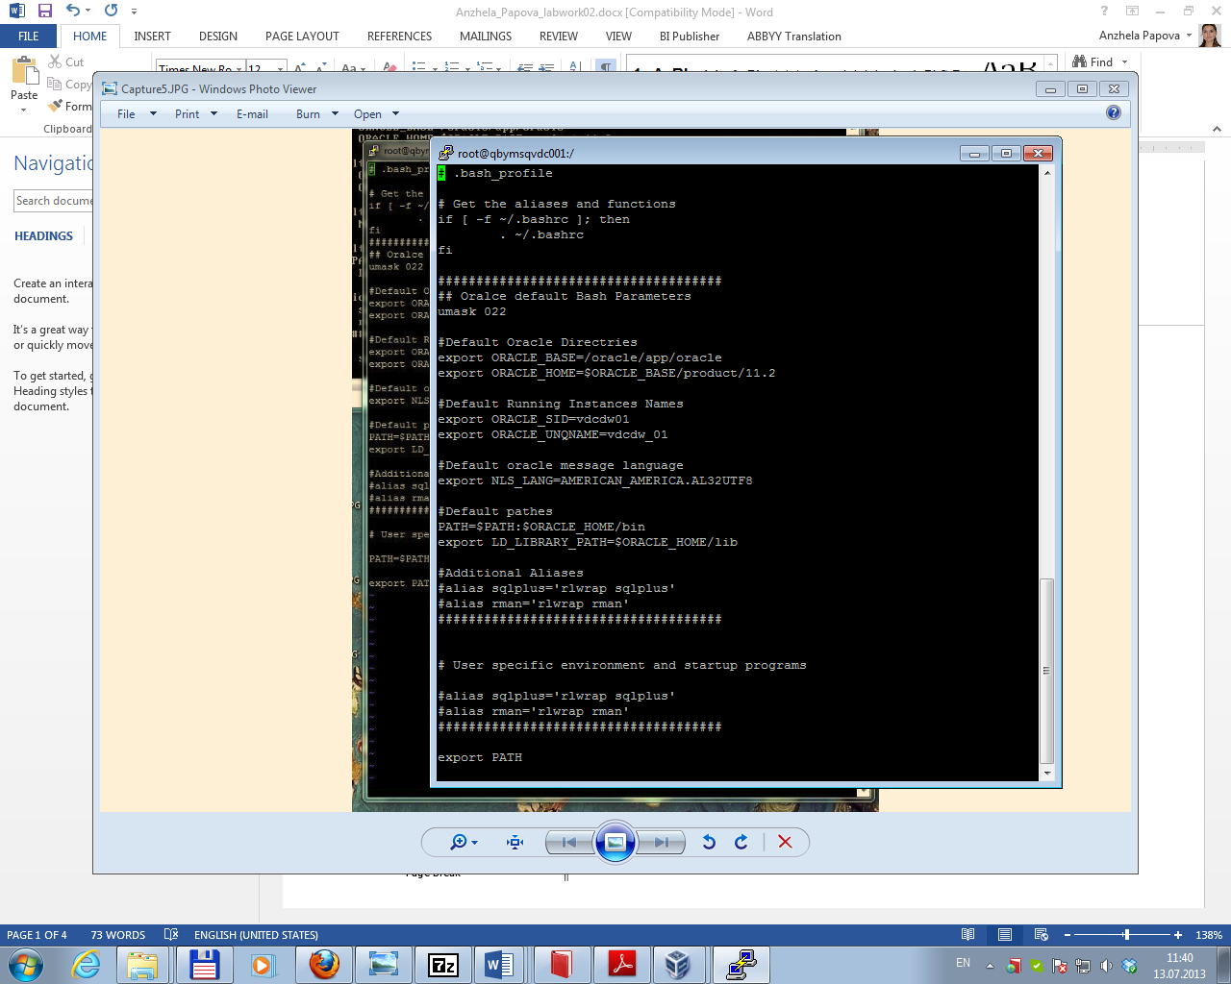  
Allocating Shared Resources

Disk space was checked by running command: df -a.

To allocate a big size of shared memory in the /etc/rc.d/rc.local file was added:

umount tmpfs

mount -t tmpfs shmfs -o size=4g /dev/shm

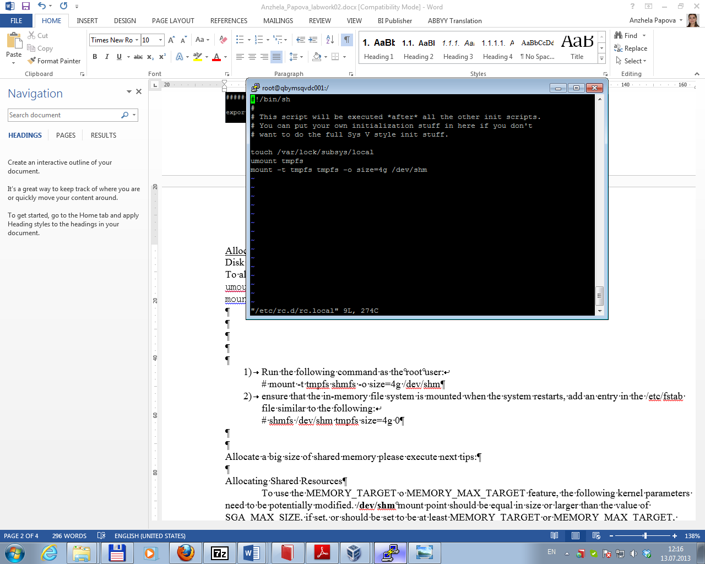

Then in the /etc/fstab file was added:

shmfs /dev/shm tmpfs size=4g 0 0

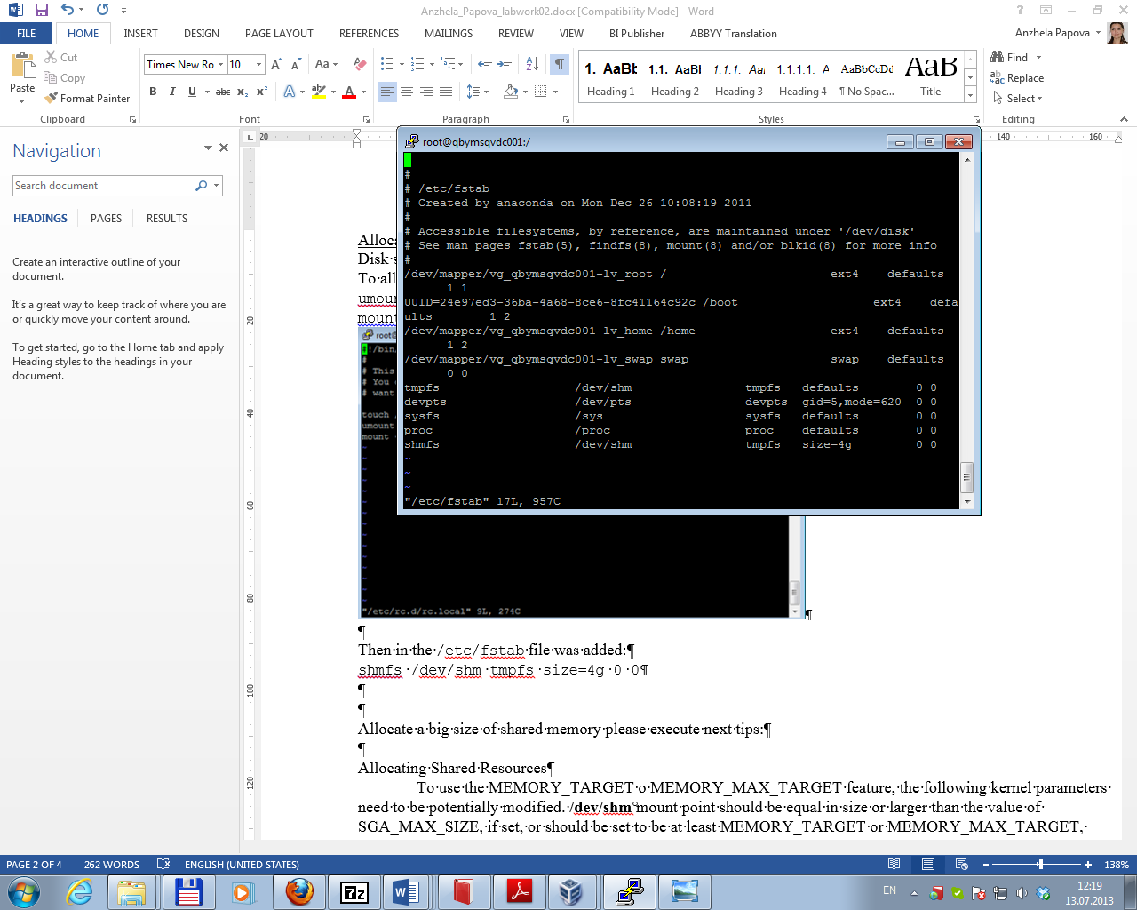

Result of allocating shared resources is presented below (command: df –a):

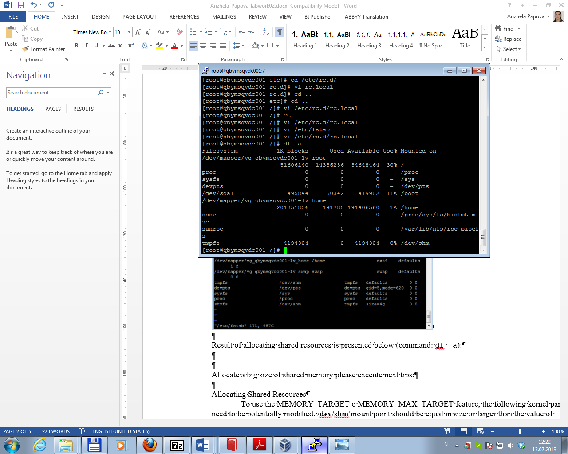

**Task 3. Install Oracle 12c**

Task 3.1 Running and configuring the xserver

Xserver Xming was installed and configured (no access control):

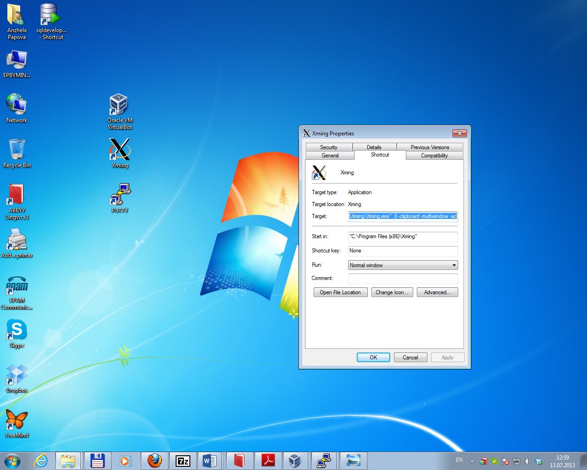

Task 3.2 Install Database software only

Oracle Distributive was copied to folder /oracle/install; then – extracted by running commands:

unzip linuxamd64_12c_database_1of2.zip

unzip linuxamd64_12c_database_2of2.zip

Connection - as Oracle User

After that Database software was installed step by step.

Task 3.3 TNS Listener Configuration

TNS Listener was configured by running Oracle Net service configuration Assistant:

netca

Listener Status is presented below:

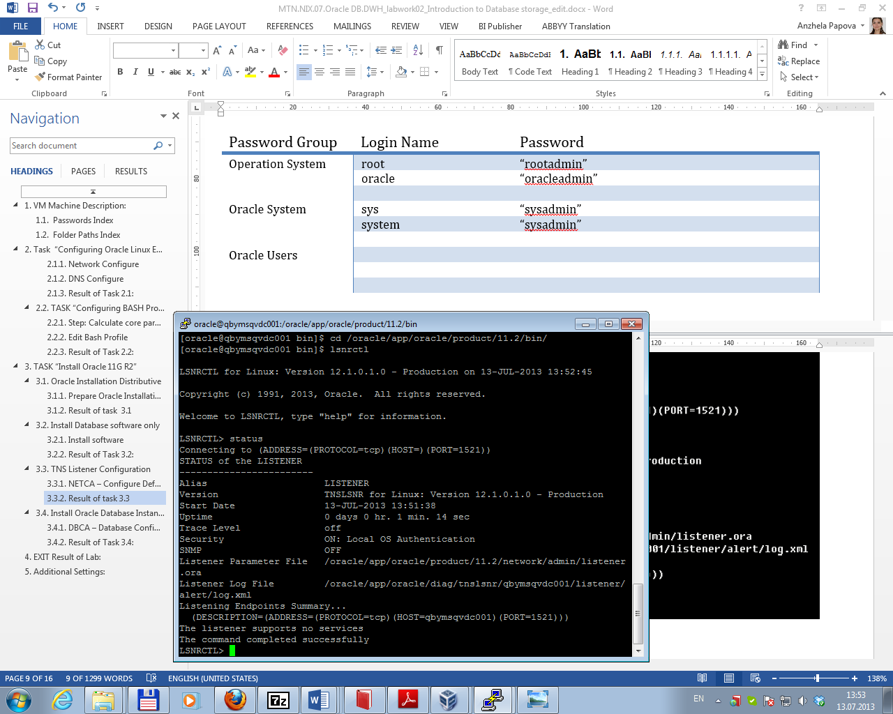

Description of configuration file was gotten by running command:

vi /oracle/app/oracle/product/11.2/network/admin/listener.ora

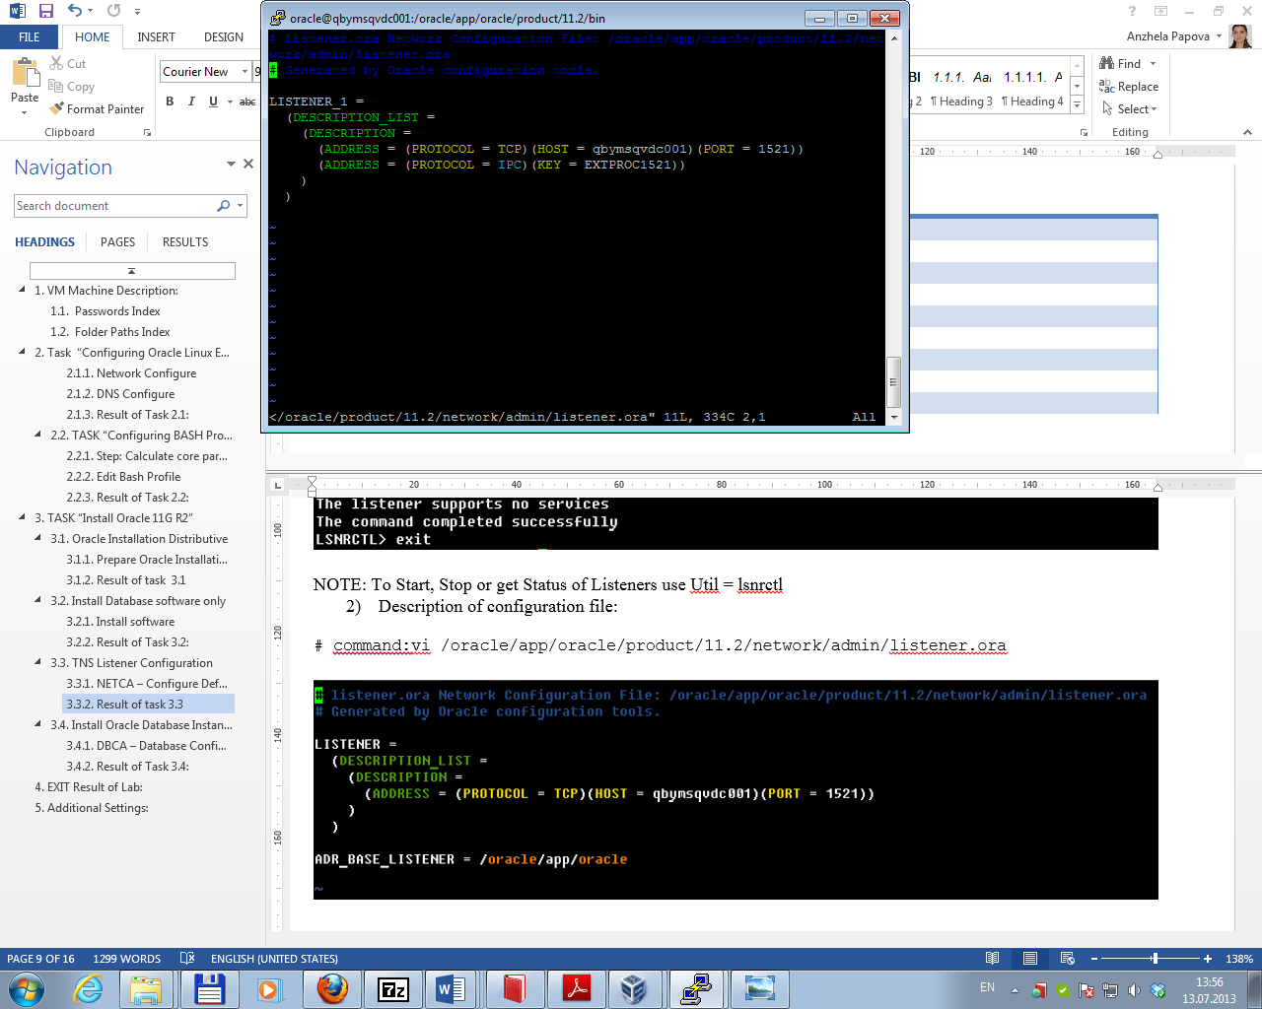

Task 3.3 Install Oracle Database Instance

Oracle Database Instance was installed by running Oracle Net service configuration Assistant:

dbca

Database configuration is presented below:

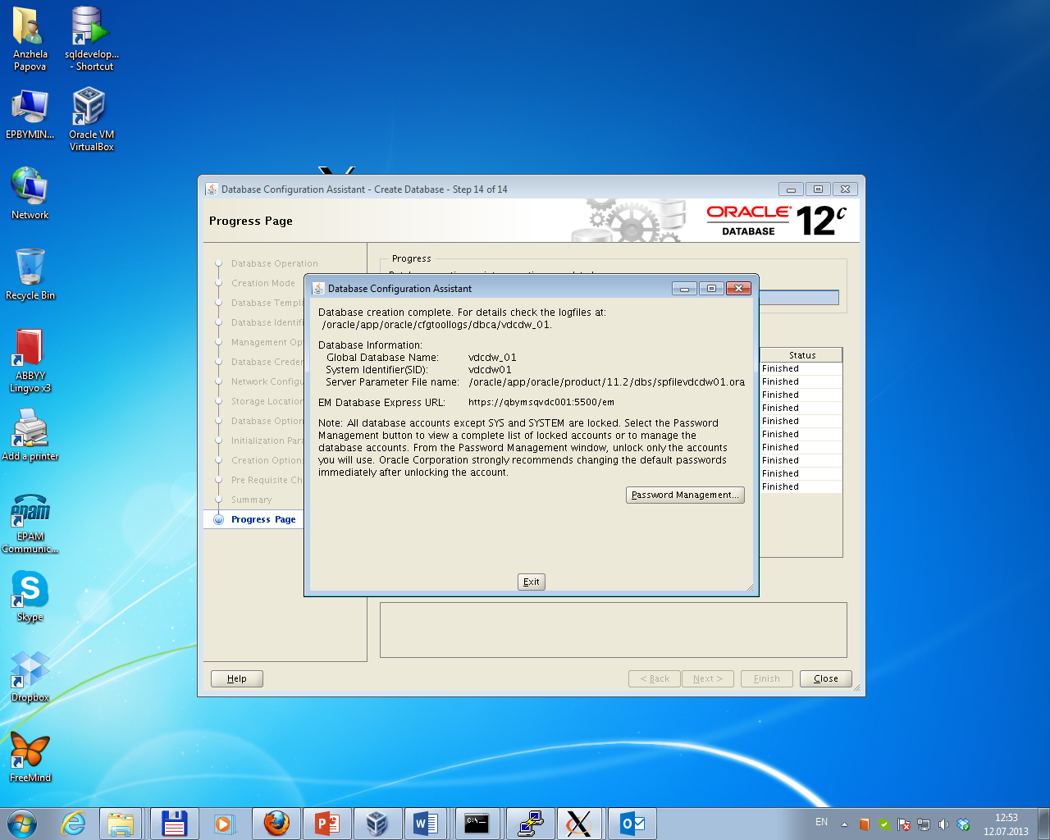

Task 3.4 Start Oracle Database Instance

Oracle Database Instance was started by running commands:

sqlplus / as sysdba

startup open;

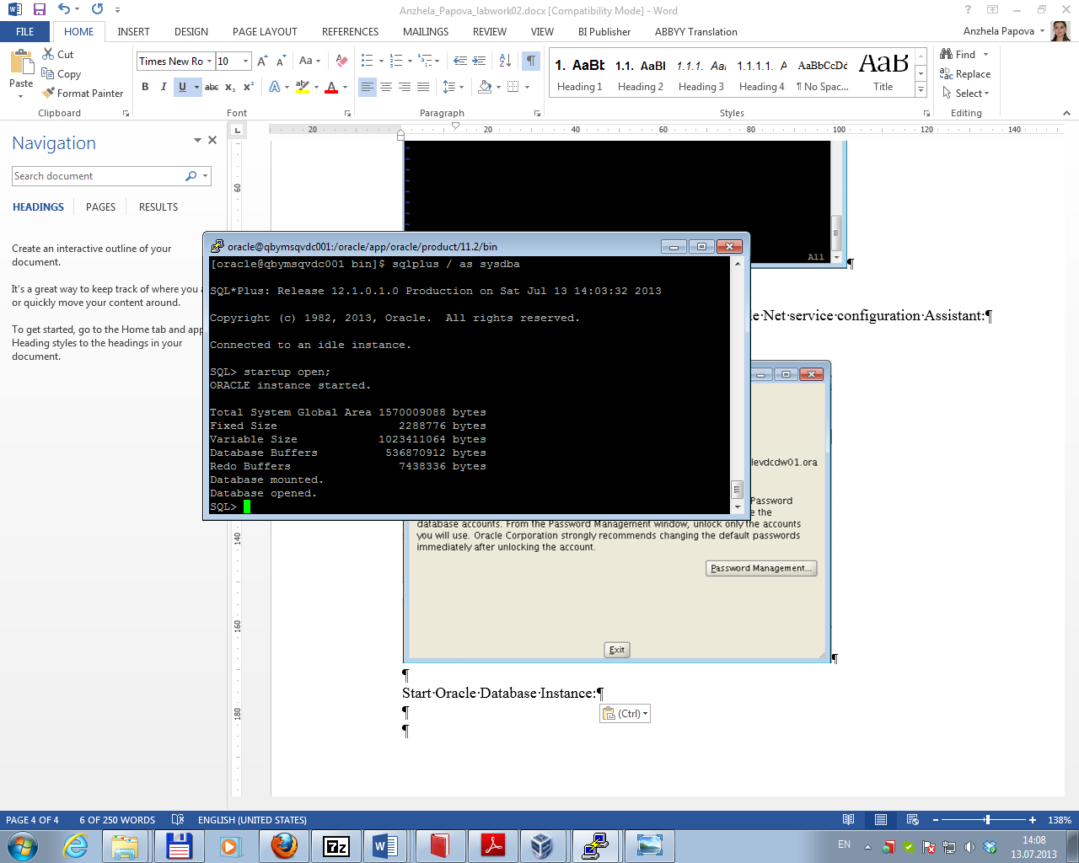

Task 3.5 Auto Rerunning Oracle Instances

Auto Rerunning Oracle Instances was set by editing of configuration file /etc/oratab:

